Adjunct

🔹 What is Adjunct
# Source: AI Source: Provided by: [Data Path: Persons Table -> ID Column: 1, Name_En Column: Motasem Essam] -> From: [Chatgpt (GPT-4-turbo)] on [8/3/2025]
An adjunct is a non-essential part of a sentence that adds extra information such as time, place, manner, reason, or condition.
Removing an adjunct does not change the core grammatical structure or meaning of the sentence.
🧠 Think of an adjunct as the “optional detail” that answers:
When? Where? Why? How? How often? Under what condition?

✅ Key Characteristics of Adjuncts:
# Source: AI Source: Provided by: [Data Path: Persons Table -> ID Column: 1, Name_En Column: Motasem Essam] -> From: [Chatgpt (GPT-4-turbo)] on [8/3/2025]
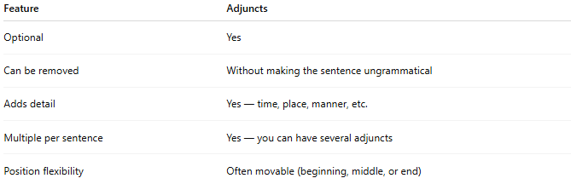
Feature | Adjuncts
Optional | Yes
Can be removed | Without making the sentence ungrammatical
Adds detail | Yes — time, place, manner, etc.
Multiple per sentence | Yes — you can have several adjuncts
Position flexibility | Often movable (beginning, middle, or end)

✅ Types of Adjuncts:
# Source: AI Source: Provided by: [Data Path: Persons Table -> ID Column: 1, Name_En Column: Motasem Essam] -> From: [Chatgpt (GPT-4-turbo)] on [8/3/2025]
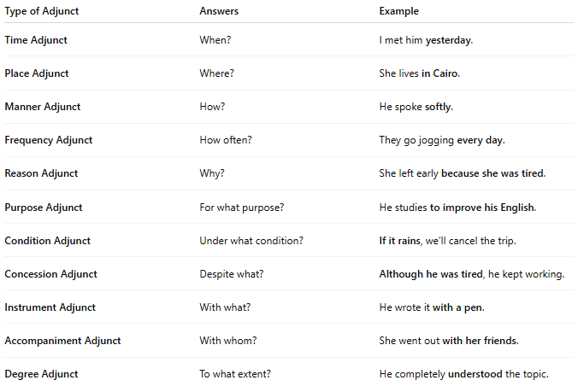
Type of Adjunct | Answers | Example
Time Adjunct | When? | I met him yesterday.
Place Adjunct | Where? | She lives in Cairo.
Manner Adjunct | How? | He spoke softly.
Frequency Adjunct | How often? | They go jogging every day.
Reason Adjunct | Why? | She left early because she was tired.
Purpose Adjunct | For what purpose? | He studies to improve his English.
Condition Adjunct | Under what condition? | If it rains, we’ll cancel the trip.
Concession Adjunct | Despite what? | Although he was tired, he kept working.
Instrument Adjunct | With what? | He wrote it with a pen.
Accompaniment Adjunct | With whom? | She went out with her friends.
Degree Adjunct | To what extent? | He completely understood the topic.

✅ Forms of Adjuncts:
# Source: AI Source: Provided by: [Data Path: Persons Table -> ID Column: 1, Name_En Column: Motasem Essam] -> From: [Chatgpt (GPT-4-turbo)] on [8/3/2025]
Adjuncts can take various grammatical forms:
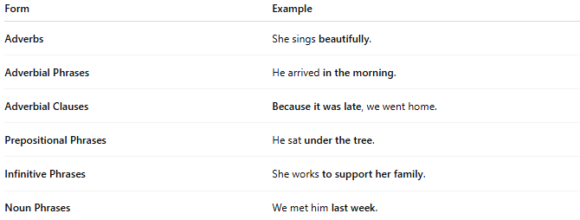
Form | Example
Adverbs | She sings beautifully.
Adverbial Phrases | He arrived in the morning.
Adverbial Clauses | Because it was late, we went home.
Prepositional Phrases | He sat under the tree.
Infinitive Phrases | She works to support her family.
Noun Phrases | We met him last week.

✅ Adjunct vs Complement:
# Source: AI Source: Provided by: [Data Path: Persons Table -> ID Column: 1, Name_En Column: Motasem Essam] -> From: [Chatgpt (GPT-4-turbo)] on [8/3/2025]
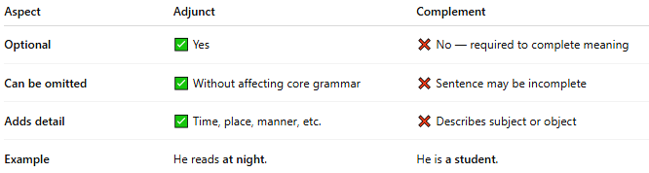
Aspect | Adjunct | Complement
Optional | ✅ Yes | ❌ No — required to complete meaning
Can be omitted | ✅ Without affecting core grammar | ❌ Sentence may be incomplete
Adds detail | ✅ Time, place, manner, etc. | ❌ Describes subject or object
Example | He reads at night. | He is a student.

✅ Position in Sentence:
Adjuncts are flexible in placement:
- Beginning: After dinner, we played cards.
- Middle: We often go hiking.
- End: We played cards after dinner.

📝 Summary:
# Source: AI Source: Provided by: [Data Path: Persons Table -> ID Column: 1, Name_En Column: Motasem Essam] -> From: [Chatgpt (GPT-4-turbo)] on [8/3/2025]
- Adjuncts provide additional but optional information.
- They include adverbials, prepositional phrases, and clauses.
- Common types: time, place, manner, reason, condition, etc.
- Removing an adjunct does not affect sentence grammar, only detail.

